**Overall Procedure of Image Segmentation**

The image segmentation process involves several key steps to accurately predict cloud coverage using a machine learning model. The steps are outlined below:

1. **Viewing Images**:
   * Begin by manually inspecting satellite images to identify and mark cloud intervals.
2. **Creating Training Data**:
   * Generate training images from the marked intervals to accurately represent both cloud and no-cloud conditions.
3. **Training Model**:
   * Train the model using transfer learning with ResNet-50 to ensure accurate predictions.
4. **Generating Predictions and Post-Processing**:
   * The images are segmented into 45 smaller boxes (15x3 grid). The 5 boxes on the right are excluded from the analysis due to insufficient pixel data.
   * The machine learning model predicts cloud presence for boxes 0 to 8 (labeled in green). These predictions are then propagated using the expected motion of the ISS to adjacent boxes, following the arrows, effectively extending the prediction across the image.
   * For example, the prediction for box 0 is extended to boxes 9, 12, 15, and 18.

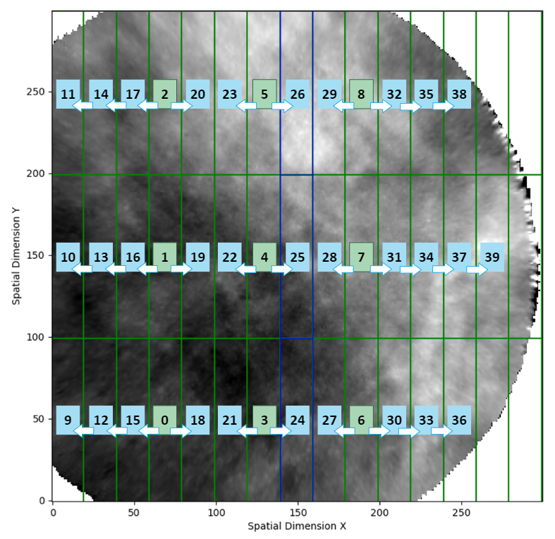

1. **Incorporating Predictions into the NetCDF File**:
   * The segmented boxes are mapped to a 2D array.
   * Two new dimensions are added: y_box_along_track (size=3) and x_box_cross_track (size=14).

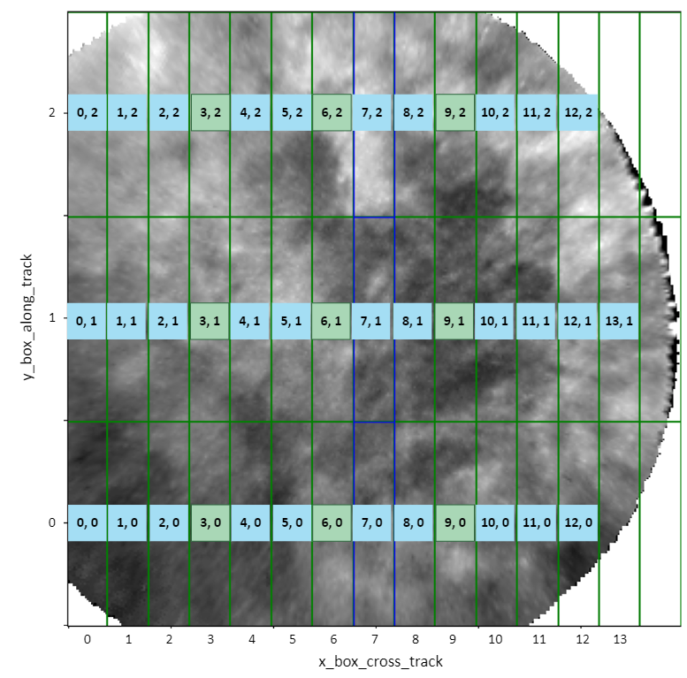

* + The MLCloud variable is included with dimensions (time, y_box_along_track, x_box_cross_track).

1. **Viewing Results**:
   * Visualize the final processed data, highlighting cloud regions within each segmented image.

**MLCloud Variable Description**

* **MLCloud** is a 3-D variable with dimensions (time, y_box_along_track, x_box_cross_track) where each value is an integer between 0 and 100. The value represents the rounded percentage of the predicted cloud probability for the box (x_box_cross_track, y_box_along_track) at the time frame time.
* A value of 0 indicates 0% predicted probability for cloud, while a value of 100 indicates 100% predicted probability for cloud.
* The default threshold value is 50:
  + Values >= 50 are considered cloudy.
  + Values < 50 are considered clear.
* **Note**: This threshold can be adjusted by the user to make cloud detection more or less strict, depending on specific needs.